**PROJECT DOCUMENTATION**

**CSE 299**

**Junior Design Course**

**Semester: Spring 2019**

**Section: 2**

**Group: 1**

**Submitted by:**

Name: Sakib Mahmud

ID: 1620802042

Email: [sakib.mahmud01@northsouth.edu](mailto:sakib.mahmud01@northsouth.edu)

**Submitted to:**

Shaikh Shawon Arefin Shimon

Email: shaikh.shimon@northsouth.edu

**Introduction:**

This app will be the ultimate cooking guide. There are days when we have very little ingredients or way too many and can’t decide what to cook. This app will be our life savers in those days. Just select the ingredients you want to cook with and search. A variety of cuisines and recipes will be displayed from which you can choose accordingly. Another fun element added is your location, so the top searches will show the recipes you are most likely to eat.

**Project Motivation:**

There are hundreds of websites where you can get recipes for anything. But from my experience of cooking and baking I know for a fact that not all the recipes in the internet are trustworthy. In our app we will only update the recipes from trusted websites and sources and try to be as minimalistic as possible in terms of ingredients. Our motivation is time management and we want to save as much time as possible so that you don’t have to surf the internet for a recipe just fill out what you have and what you feel like having and how much time you want to spend and our app will provide you with the recipe.

**Technical Specifications:**

Language of preference: java

Project built on: android studio

Designing Mock-ups: balsamiq

Logo: adobe photoshop

Database: firebase

**Business Idea:**

Main target audience are the college students. People who really don’t have much experience with cooking and rely on websites. Digital marketing via Instagram and Facebook will play a vital role and will make people aware of the app.

**App Features:**

* Search option to filter recipes
* Detailed/ reliable recipes
* Time mentioned so users can choose which ever they want
* Region specified (recipes that are suited to that particular region will show first)
* Age specified (users of the app who are younger will be shown the recipes with shortest cook time)
* Anyone can upload their recipes with photos of it, and others can rate them and ask questions in that thread.

**Monetization:**

The main idea of earning revenue through this app is through mobile app advertising. We are going to get paid each time our users interact with ads in their app. The ads will be normally integrated directly into the app experience.

**Functions:**

In this app the user can upload their recipes along with the photos in their profile and other users can like and comment to ask them more about the recipe. Users can also view and follow other users and even message them privately.

**Login Activity**

When the user opens the app, he/she is asked to login to their account using their email ID and password. If they don’t have any account in this app they can navigate to the register activity to register their account

**Register Activity**

New users can register in the app using their email ID, name and password. A verification email will be sent to their given email ID, before verifying the email, they cannot login to the app.

**Home Activity**

The home activity is divided in three fragments; camera fragments, home fragments and messages fragments. In the camera fragment user can take a photo and upload it instantly to their profile feed. In the home fragment the user can view their followings posts, like their posts and comment on them. In the message fragment the user can privately message other users.

**Search Activity**

In the search activity the user can search the recipe they are looking for or the ingredients used for it or other users.

**Share Activity**

In the share activity the user can upload photos from the gallery or directly take pictures and upload them in their user profile along with captions and tags.

**Likes Activity**

In the likes activity the user can check their notification, who liked their recipes, commented on them or following them

**Profile Activity**

The profile activity is divided in three sections; top bar, middle section and the grid view. The top bar is divided in two section, in one the user name is written and on the other there is an image view clicking on which navigates you to account settings.

In the middle section there is a user profile picture and three counters; followers, following and posts. And bellow that there is an edit profile button clicking on which takes you edit your profile activity.

The user’s uploaded photos are viewed in a scrolled grid view in the last section of the user profile.

**Account Setting**

Account settings have two buttons, one navigates you directly to the edit profile settings and the other one signs you out.

**Edit Profile**

The user can edit their information given from here; user name, display name, phone number and profile picture.

**Sign Out**

User can sign out by clicking on the sign out button.

**Bottom Navigation Bar**

The bottom navigation bar helps the user to navigate through all the activities. Home activity, search activity, share activity, likes activity and profile activity.

**Screenshots:**

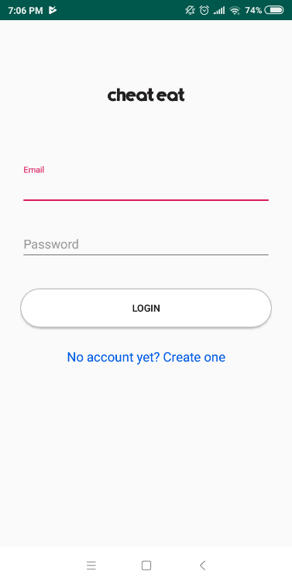 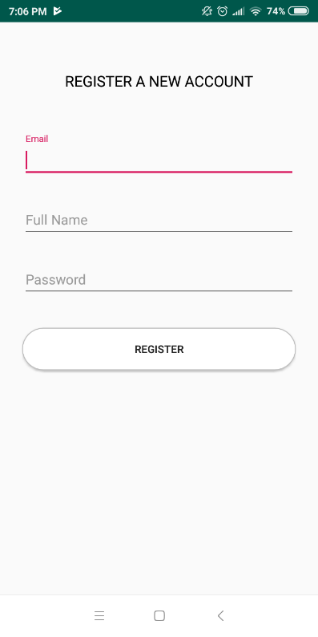

Login Screen Register Screen

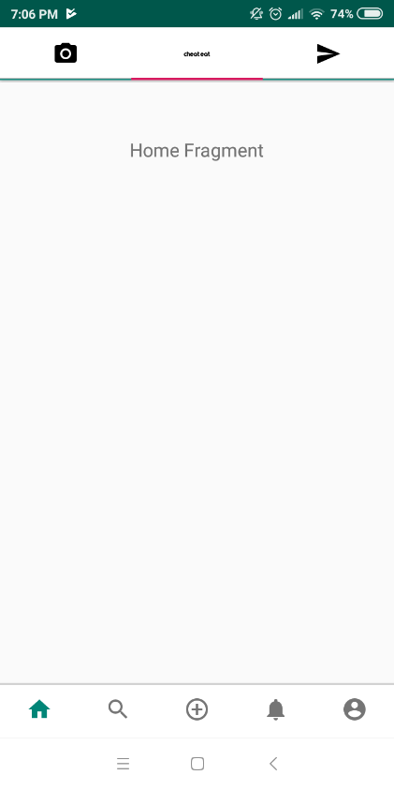 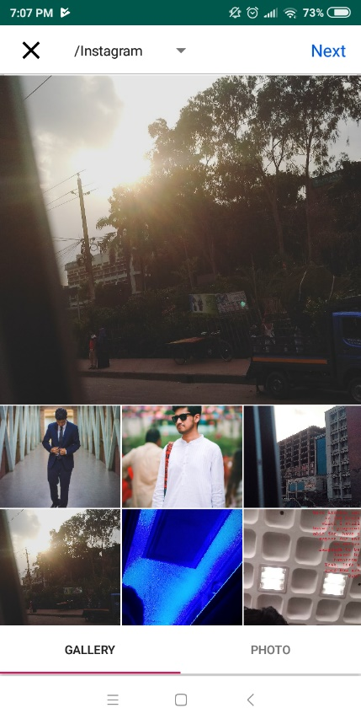 Home Screen(incomplete) Share Screen

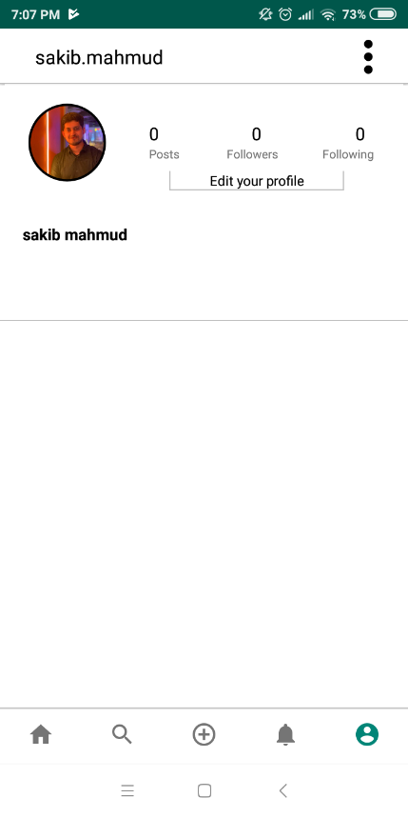 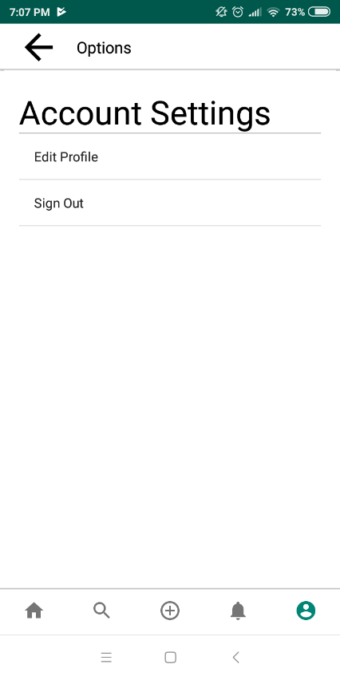

User Screen Account Setting Screen

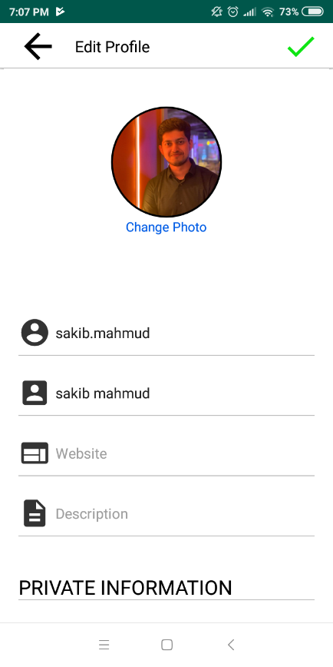 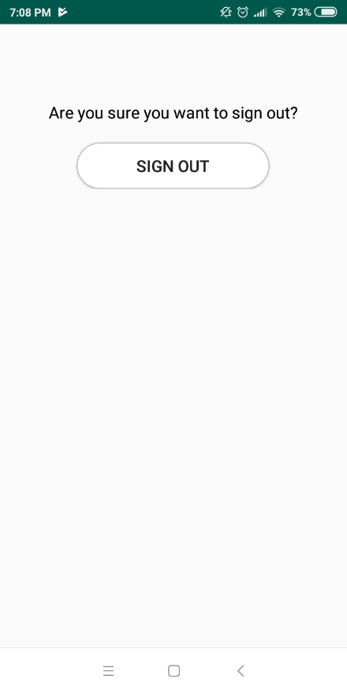

Edit Profile Screen Sign Out Screen

**Links:**

GitHub: <https://github.com/nsuspring2019cse299sec2/Group-1>

Trello: <https://trello.com/b/OnPOlF2N/food-app>